Technical Report Of Project

### ONLINE BUS BOOKING SYSTEM

N PRAJWAL CHANDRA (150001019)

B HARSHA VARDHAN (150001003)

Acknowledgement:

For us, the prime motivation for doing this project is to get a hold on the fundamental concepts that form the basis of database design.

PROJECT DESCRIPTION:

The motto of Online Booking System is to reduce major defects in the present bus reservation system. Bus reservation system deals with maintenance of records of details of each passenger, employee, operators, agents and also schedule of each and every bus. It provides bus travelers, the most uncomplicated and hassle-free booking experience ever. Choose your destination, select bus based on different filters, view the seat layout, choose convenient seats, and book your ticket in just a few clicks.

END USER:

Any person with internet connection can book/cancel the ticket of his/her need by just visiting site.

FEATURES:

This project keeps track of following modules:

* Avail Online Reservation.
* Availability of seats of a particular bus.
* Cancellation of tickets.
* Online payment.

DEVELOPMENT:

**HTML** is used to develop web pages (front end i.e, User Interface) and **PHP** and **MySQLi** for back end.(data processing)

##### DATABASE:

Database contains all information regarding buses, operators, passengers, reserved and available tickets, coupons, payment, feedback, boarding points in different cities,routes etc.

It contains the following tables:

* Buses
* Operators
* Routes
* Passengers
* Payment
* Seats
* Coupons
* Feedback
* Boarding points
* Via
* Via-days

DESCRIPTION OF TABLES: **(Sample Screenshot attached for each table )**

* **Buses:**

Contains information of the different buses provided by different operators.It includes ID given to bus, type of bus like A/C or Non A/C; type of seats like Sleeper, Semi Sleeper, VOLVO etc.

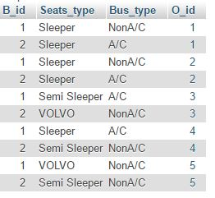

* **Operators:**

Contains information regarding operators(service providers) which include Operator Id,

Name, Email, Contact number.

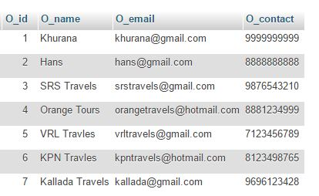

* **Routes:**

Contains information of routes for which different operators provide buses.Information includes Departure City, Arrival City, Route Id.

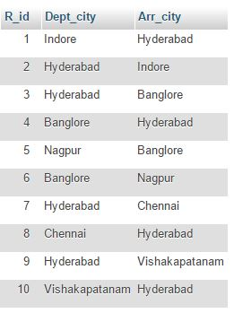

* **Passengers:**

Contains up to date information of all the passengers who have booked seats for their journey.It includes passengers Id(PNR number), name, gender, age, journey date, transaction Id of their payment,contact number, email etc.,.Note that contact and email of a single person is taken in case of mulitple ticket booking.

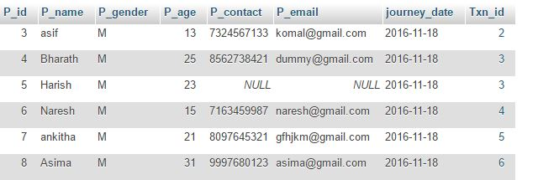

* **Payment:**

Contains information regarding payment made by passengers for their booking which include final amount received,Transaction Id, Method of payment, Card number(Debit or Credit).

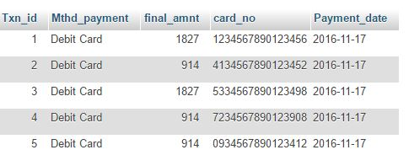

* **Seats:**

Contains information of all seats booked for a particular bus, route, date, Passenger id who has booked the ticket.

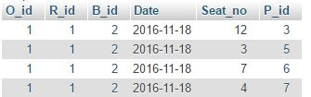

* **Coupons:**

Contains information of discount coupons provided to passengers which include coupon code, valid date, discount %, Max discount.

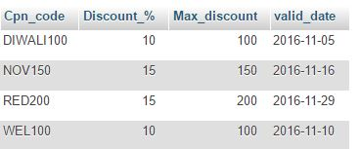

* **Feedback:**

This table contains all feedback given by passengers which include Feedback id,passenger Id by whom feedback is given,Rating and Comments.

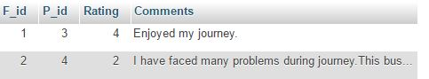

* **Boarding Points:**

Contains information of boarding points in different cities.

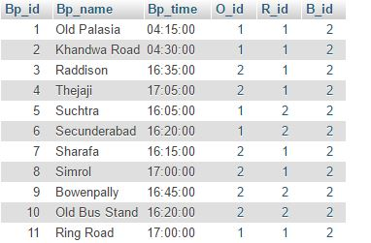

* **Via:**

Contains information of fare,departure time, arrival time of all buses from different operators going in differenet routes.

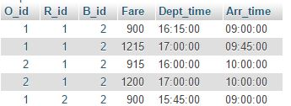

* **Via-Days:**

Contains information regarding on what days buses will travel in different routes.

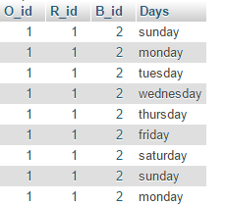

#### TRANSACTIONS:

The three main transactions which constitute this entire project are Booking, Cancellation and Feedback.

1. Booking:

This transaction includes many operations starting from searching of buses based on input given by user till inserting all the validated data into corresponding tables after successful payment by passenger.

|  |  |  |
| --- | --- | --- |
| Table involved | Data inserted | Data extracted |
| Operators | -- | Operator name |
| Buses | -- | Bus type, Seats type, |
| Via | -- | Fare,Departure time,Arrival time, |
| Via-days | -- | Days |
| Passengers | Name,age,gender,contact number,txn id,email,journey data,Id | -- |
| Seats | Seat number which are booked | Seat number |
| Payment | Txn id,method of payment,card no.,final amount, payment date | -- |
| Coupons | -- | Max discount,discount% ,valid date |

**Different operations performed : (order is followed)**

1. Searching for buses based on given input of Departure city(from), Arrival city(to), Journey date(On).Date is converted to day and **SELECT** operation is performed on multiple tables using **JOIN** and results are displayed.
2. Different sorting options are available for filtering the results obtained after submitting the input.The different criteria for filtering results are price, bustype(A/C or NonA/C), Deptarture time and Arrival time.
3. After selecting bus layout of seats is displayed.**SELECT** operation is performed on **seats** and seat button which are already booked are disabled so that it can not be clicked.At the same time another **SELECT** operation is performed on **boarding_points** table to display boarding points which are present in that particular departure city.
4. Next passengers details are taken from user and validated.If all constraints in the input form are satisfied then passenger is directed to payment page.
5. .There is coupon facility to avail discount on entering valid coupon.**SELECT** operation is performed on **Coupons** table to check if the entered coupon code is valid. If valid, discount is given and payment details (Card no., CVV etc.,) are taken as user input.
6. If the constraints for payment input are satisfied then booking process is done and following operations are performed:

* **INSERT INTO** on **passengers** table.
* **INSERT INTO** on **seats** table.
* **INSERT INTO** on **payment** table.
* **INSERT INTO** on **applied-to** table.

1. Cancellation:

|  |  |  |
| --- | --- | --- |
| Table involved | Data updated | Data extracted |
| Passengers | Delete selected passengers tuple | Passengers Id,Journey date |
| Seats | Delete selected seat tuple | Seat numbers booked by user |
| Payment | Final amount is updated if amount is refunded | Transaction Id |

**Different Operations performed:**

1. Transaction Id provided by user is verfied by performing **SELECT** operation on **payment** table.
2. All the seat numbers with that transaction id are displayed by performing **SELECT** on **passengers** and **seats.**
3. After selecting seat numbers to cancel tickets the journey time(departure time) is compared with present time and depending on the difference, amount is refunded based on cancellation policy.

* **DELETE** operation on **seats** table.
* **DELETE** operation on **passengers** table.
* **UPDATE** operation on **payment** table.

1. Feedback:

|  |  |  |
| --- | --- | --- |
| Table involved | Data inserted | Data extracted |
| Passengers | -- | Passengers Id |
| Feedback | Rating and comments | -- |

**Different Operations performed:**

1. PNR number taken as input is verifed by **SELECT** operation on **Passengers**.
2. **INSERT INTO** operation on **Feedback** table.

#### INTEGRITY CONSTRAINTS:

Integrity constraints applied in this project mainly constitute Referential Integrity constraints(foreign keys).The following are foreign key constraints applied:

|  |  |  |  |
| --- | --- | --- | --- |
| Referenced In | Column name | Referenced From | Column name |
| Buses | O_id | Operator | O_id |
| Feedback | P_id | Passengers | P_id |
| Boarding Points | O_id | Operator | O_id |
| Boarding Points | B_id | Buses | B_id |
| Boarding Points | R_id | Routes | R_id |
| Passengers | Txn_id | Payment | Txn_id |
| Seats | O_id | Operator | O_id |
| Seats | R_id | Routes | R_id |
| Seats | B_id | Buses | B_id |
| Seats | P_id | Passengers | P_id |
| Via | O_id | Operator | O_id |
| Via | R_id | Routes | R_id |
| Via | B_id | Buses | B_id |
| Via-days | O_id | Operator | O_id |
| Via-days | R_id | Routes | R_id |
| Via-days | B_id | Buses | B_id |